Communications Board Report – Val Thorpe

June 2019

Events

Our June 14th Full Moon hike at Jockey hollow maxed out at 22 attendees and every person who participated in the hike (led by Adam Palmer with owl calling Emile DeVito) remained on-site for stories by the campfire (led by Eric Olsen, Park Ranger). According to Adam, this event was a smash hit! Next up, our Members Only/Major Donors hike at the Great Swamp National Wildlife Refuge on June 27, 6:00-8:00 PM.

Great Swamp Great Music Festival - 2019

“The scene that day was all color, joy, play, music, friends old and new, beach balls, beer, dancing, everything absolutely picture-perfect.” -Kit Stinson, GSWA Advisory Council member and Music Festival Promotions Committee
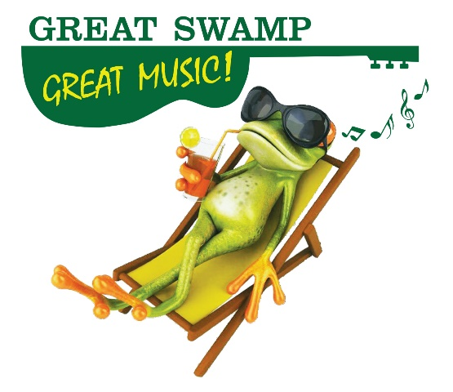
Sunday, June 9 was a spectacular day of bright blue skies and puffy white clouds for our 2nd Annual Great Swamp Great Music festival, leaps and bounds better than last year’s weather. We are in the process of reconciling our numbers, but it preliminary results indicate that the revenue for the festival, our 2nd largest fundraiser of the year, doubled over last year’s inaugural event. Additionally, we drew a crowd of approximately 650 men, women, and children – that’s nearly 300 attendees over last year!

This year we added a 5th band and an additional hour to the event, which ran 12:00-5:00 PM. Once again, Wade Kirby served as our emcee and did a fantastic job spotlighting our sponsors and introducing the bands. Jeff Webb kicked things off and entertained the crowd between band sets. The bands, who all generously played for free, really brought it! It was an afternoon of incredible music and smiles.

The field was filled with spectators of all ages, relaxing on blankets and chairs. Others set up under the big tent to escape the sun. Children played with frisbees, jump ropes, beachballs and more that we provided for their entertainment. Both Delta Dental, one of our sponsors, and Back to Nature, a merchandise vendor, brought the game cornhole, where people held friendly competitions throughout the afternoon. Pictures will be posted on the website and Facebook shortly.

We are grateful to Nic Platt for once again offering us the use of the magnificent Hartley Farms Polo Field for this exciting event. Additionally, thank you to the board for all your efforts in promoting the event far and wide. And, nearly every board member attended!

Festival details:
- Numbers are still being finalized. Currently we believe the profit will be close to double that of last year’s.

- $29,000 was secured with 14 sponsors and 2 supporters (big shout out to Rick and Wade!) Top 7:
- Normand Real Estate Partners ($5000)
- Peapack-Gladstone Bank and Peapack Private Wealth Management ($5000)
- Debra & John Apruzzese ($2500)
- Atlantic Health System ($2500)
- Delta Dental of NJ ($2500)
- Glenmede Investment and Wealth Management ($2500)
- Adrienne & Dillard Kirby ($2500)

- Attendees
  - Still confirming, approximately 650
  - ~340 attendees purchased tickets at the gate

- 5 local bands + guitarist/singer donated their time and talent
  - Lenox Underground
  - LogJam
  - Not Enough Jeffs
  - Purple Hayes
  - The Gammon Brothers
  - Jeff Webb

- 5 food vendors
  - Minuteman – Bernardsville
  - Summer Daze – Basking Ridge
  - Pie Oh My – Little Falls
  - Lebanon Boro General Store – Lebanon
  - Friendlys – Morris Plains

- There were a lot of free perks for festival goers
  - New Jersey American Waters brought “Puddles” a potable water system and cups
  - Caricatures and face painting
  - 300 Tickets to MARS Essex Horse Trials
  - Parking

- Alcohol – beer and wine were available for purchase
  - Washington House of Basking Ridge again donated their firetruck/beer tap for the day
  - USA Wine Traders of Chatham again give us great discounts for the wine we sold
- 5 merchandise vendors + 3 sponsor tables
  - Crafts by Alice
  - Back to Nature plants and honey
  - Secret Garden Goat Soap
  - Patricia & Paul Oils and vinegars
  - Scooch a Mi “accessories that give back”
  - Delta Dental of NJ
  - Glenmede Investment and Wealth Management
  - Peapack-Gladstone Bank and Peapack Private Wealth Management

- VIP tent packages – we provided 3 VIP tents as prizes for various galas. We will expand upon that offering next year.

- A debrief was held with the staff on June 12 to capture what worked, and what could be improved upon next year. Board input is welcome!

Press - GSWA in the News
Great Swamp Great Music Festival was spotlighted in the local papers including NJ Hills Media:
- May 16 – press release
- May 29 – Sally & Val on local radio program “Happy to Help” a weekly radio show featuring nonprofits, foundations and volunteers to encourage people to engage with a cause they care about and realize the mutual benefit of helping our fellow human beings.
- May 30 (1/4 page ads in 6 local papers [courtesy of Kit Stinson] and 8 NJ Hills Media papers)
- June 6 (front page of Observer Tribune)
- June 13 (Photos and summary of event on front page of Happenings in the Hills)

Chairman Appeal 2019
A letter from Board Chairman, Nic Platt, was sent to 1100 households with the theme, “Action without history.” More to follow.

*Please use the links below to easily share GSWA’s social media! Simply copy the info and paste into an email to your families, friends, and colleagues:

Please support the Great Swamp Watershed Association (GSWA) by liking and following us on social media!

Facebook: https://www.facebook.com/GreatSwamp/
Instagram: https://www.instagram.com/greatswampnj/
Twitter: https://twitter.com/GSWA
Learn more about us at our website: www.GreatSwamp.org

